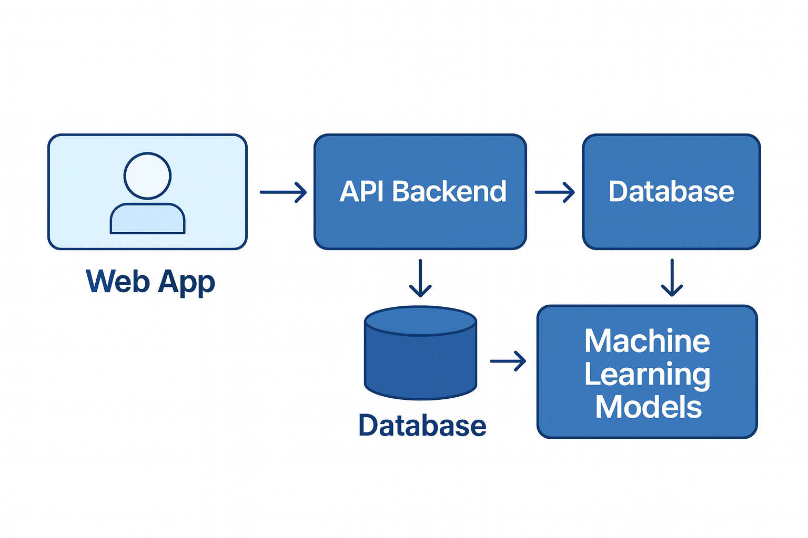 ( OPEN DEEP RESEARCH ARCHITECTURE )

